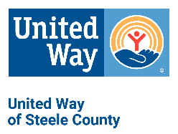

SHORT FORM Request for Funding Checklist
Agency:_________________ Program:_________________

Complete and include one copy of checklist with each proposal.

IMPORTANT NOTE: You must submit a complete set of Required Documents A for each program request in multiple areas of concern.

 | REQUIRED DOCUMENTS A
□ | Please upload the following documents within the web form as requested:  □ Form 1: 2025 Work Plan and Evaluation  □ Form 2: 2025 Agency Budget and Reserves  □ Form 3: 2023 Geographic and Demographic Final Report (existing programs)  □ Form 1: 2023 Evaluation Outcome Report – with Actual Totals Added (existing programs)  □ 2024 Board of Directors list, including professional affiliation and contact information  (address, telephone, and email)  □ 2023 Program Testimonials
IMPORTANT NOTE: Please upload the following documents within the web form as requested.

 | REQUIRED DOCUMENTS B
□ | 1 copy 2023 year-end financial statement including balance sheet and year end profit & loss sheets.
□ | Signed copy of Agency Correspondence Policy
□ | Signed copy of Counterterrorism Compliance Form

DUE DATE
Proposals due in the UWSC office: 3/29/2024 by 4:00 pm
Mail P.O. Box 32, Owatonna, MN 55060, or hand deliver to 1850 Austin Rd. Ste 103, Owatonna, MN 55060

