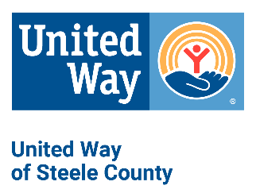
Request for Funding Checklist
Agency:_________________ Program:_________________

Complete and include one copy of checklist with each proposal.

IMPORTANT NOTE: You must submit a complete set of Required Documents A for each program request in multiple areas of concern.

 | REQUIRED DOCUMENTS A
□ | Please upload the following documents within the web form as requested:  □ Form 1: Work Plan and Evaluation  □ Form 2: Agency Budget and Reserves  □ Form 3: Geographic and Demographic Final Report  □ 2023 Form 1: Evaluation Outcome Report – with Actual Totals Added  □ 2024 Form 1: Evaluation Outcome Report – as submitted in 2022, do not alter  □ 2024 Board of Directors list, including professional affiliation and contact information  (address, telephone, and email)  □ 2025 Program Testimonials
IMPORTANT NOTE: Please upload the following documents within the web form as requested.

 | REQUIRED DOCUMENTS B
□ | 1 agency brochure
□ | 1 copy evidence of annual Federal Form 990 submission (example: cover sheet or electronic confirmation)
□ | 1 copy State Attorney General’s Office Charities Division annual report
□ | 1 copy agency by-laws
□ | 1 copy 2023 year-end financial statement including balance sheet, budget to actual, and profit & loss sheets
□ | 1 copy most recent completed audit or compilation, if performed.
□ | Signed copy of Agency Correspondence Policy
□ | Signed copy of Counterterrorism Compliance Form
□ | 1 copy proof of insurance (see list on back)

- Proof of Insurance- Please have your agent(s) send us a certificate of insurance for the following coverages you have in place, if applicable to your organization:
  - Property
  - Liability
  - Worker’s Compensation
  - Auto
  - Professional liability
  - Management (D & O, E & O, Fiduciary, EPL, Crime)
  - Other____________________________________

DUE DATE
Proposals due in the UWSC office: 3/29/2024 by 4:00 pm
Mail or hand deliver to: 1850 Austin Rd. Ste 103, P.O. Box 32, Owatonna, MN 55060

