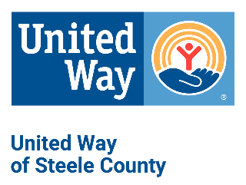
Proposal Definitions

Direct Human Services: Providing one-on-one assistance to a client, e.g., giving food or clothing, an individual counseling session, advocacy or legal advice, transportation, cash assistance, housing.

Education & Support Groups: Education or support for a group of clients (not volunteers or community members), e.g., support group, class, or training.

Individual Client: One unduplicated individual.

Family: A family is comprised of individual clients. When serving a family, report the number of families served and also the number of family members (i.e., one family gets food/four family members eat it).

Unit of Service: Every time you meet with a client or a family, regardless of the length of time of that session.

Education and Support Group Participant: One individual attending an educational session or support group.

Session/Class: One group activity, e.g., one CPR class or one child care provider training.

Education and Support Group Units of Service: One client x the number of groups attended, e.g, client A attends 10 groups = 10 units of service; client B attends 4 groups = 4 units of service; total clients = 2; total units of service = 14.

Outcomes: Program outcomes are the knowledge, skills, behaviors, beliefs, attitudes and/or conditions being changed by the program. They should be observable, measurable, and impactful (i.e., number of participants who quit smoking not the number of participants “who gained knowledge”.) These impacts, benefits or changes should answer the question, “What should program graduates know and be able to do at the time of program completion that is different than before they participated.”

Planned Outcome: The anticipated result of your services or activities.

Actual Outcome: The actual result of your services or activities.

Evaluation Tool: Technique that will be used to collect information, e.g., specific tests, questionnaire, individual or focus group interviews, observation, or document reviews.

In-Kind Goods & Services: “In-Kind Goods” are donations of items to your agency. “In-Kind Services” are volunteer hours or professional services donated to your agency. Do not include Board members in this category unless they donate professional services or volunteer in a program.

Use the following formula to calculate the estimated market value of “In-Kind Goods.” When in doubt, ask your accountant!

- New Items: Calculate current retail value

- Used Items: Calculate current market value less depreciation or what it would cost to buy this item secondhand.

- Use the following formula to calculate the market value of volunteer staff: Total volunteer hours x $29.95 (2022 federal volunteers’ rate)

200% of Federal Poverty Guidelines
