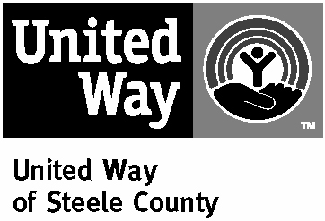
Agency Correspondence Policy*

The United Way of Steele County conducts its decision making through a democratic voting process utilizing community volunteers and Board of Directors.
In order to avoid the appearance of conflict of interest, and out of respect for the privacy of Board members and volunteers, any and all agency correspondence related to the United Way of Steele County is to be sent to
United Way of Steele County
P.O. Box 32
Owatonna, MN 55060

or e-mailed to the appropriate United Way staff person. All phone calls related to United Way business should be made to the appropriate staff person at the United Way office at 507-455-1180.
The United Way of Steele County is committed to responding to all agency requests and questions in a fair and timely manner. No correspondence related to United Way of Steele County business should be sent to an e-mail or physical address other than the UWSC office. Phone calls to Board members or volunteers at their homes or places of business will be reported to United Way staff and referred to the Community Investment Committee for appropriate consideration and action, up to and including termination of member agency status.
Agency Correspondence Policy

We have received and distributed the United Way of Steele County Agency Correspondence Policy to all staff and Board members.

Agency Name.
Executive Director signature |  | Date
Board Chair signature |  | Date

* Effective December 16, 2004, amended September 24, 2016

