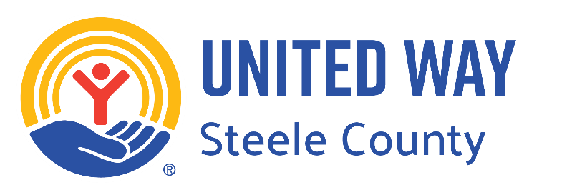

# **FAQ Sheet**

## **What is United Way of Steele County?**

United Way of Steele County is a local nonprofit organization dedicated to improving lives and strengthening communities in Steele County, Minnesota. We work collaboratively with partner agencies, businesses, and community members to address critical issues and create positive change.

## **What does United Way of Steele County do?**

We fund over 50 social service programs throughout Steele County that focus on education, financial stability, health, and meeting basic needs. Additionally, we mobilize volunteers, advocate for social change, and provide resources to help individuals and families in need.

## **How can I get involved with United Way of Steele County?**

There are several ways to get involved with United Way:

- **Make a financial donation**: Your contributions support vital programs and services in the community.

- **Volunteer your time**: Participate in volunteer opportunities organized by United Way or our partner agencies.

- **Advocate for change**: Join advocacy efforts to address systemic issues and create lasting solutions.

- **Spread awareness**: Share information about United Way with friends, family, and coworkers to help increase our impact.

## **How does United Way of Steele County allocate funds?**

We allocate funds to programs and services based on community needs and priorities identified through research and community input. Our funding decisions are guided by accountability, transparency, and a commitment to maximizing impact.

Each year, our **Community Investment Advisory Board**, made up of local volunteers, meets to review grant applications and make allocation recommendations. These recommendations are brought to our board of directors for final approval. This ensures that we remain transparent to the public in our operations and decision making process.

## **How does United Way of Steele County support local businesses?**

United Way partners with local businesses through workplace giving campaigns, employee volunteer programs, and corporate sponsorships. By participating in these initiatives, businesses demonstrate their commitment to social responsibility and community engagement.

## **Can I designate my donation to a specific program or agency?**

Yes, donors have the option to designate their contributions to a specific program or agency that aligns with their interests or priorities. However, we encourage donors to give to the Community Impact Fund, which allows us to address the most pressing needs in the community.

## **How can I learn more about United Way of Steele County?**

Visit our website at **www.unitedwaysteelecounty.org** for more information about our programs, volunteer opportunities, events, and ways to support. You can also contact us directly at (507) 455-1180 or neil.lyons@unitedwaysteelecounty.org with any questions or inquiries.

**United Way of Steele County**

245 SE 18th Street, Suite #1

PO Box 32

Owatonna, MN 55060